INTEREST MEETING
ALPHA KA MU HONOR SOCIETY
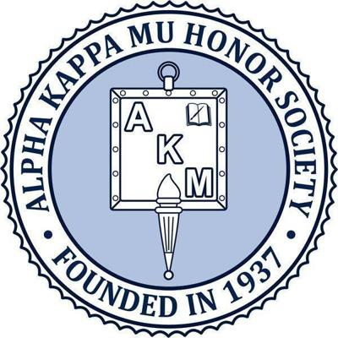

Edward Waters College Chapter Meeting
Virtual Meeting Date: March 8, 2021
Time: 12:00 am-12:30 am.
Location: Zoom Link
https://zoom.us/j/95003108428

Contact Information: Information@alphakappamu.org
Alpha Kappa Mu Honor Society is a general scholarship honor society open to junior, senior, and graduate students in all academic areas who meet the requirements of the society.
Our purpose is to promote high scholarship; to encourage sincere and zealous endeavor in all fields of knowledge and service; to cultivate a high order of personal living; and to develop an appreciation for scholarship and scholarly endeavor in others.
- All Students who have a 3.3 G.P.A. and above are eligible to join.
- Application process will be explained during the meeting.

