Call for Presentations

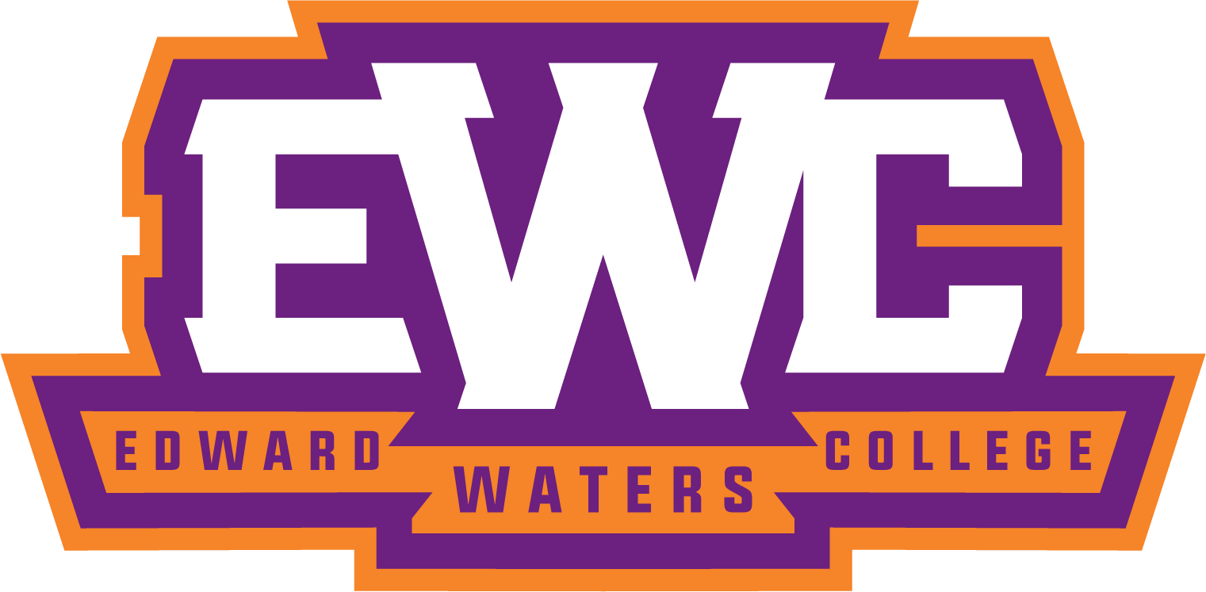

Dear Tigers,

The Center for Undergraduate Research (CUR) is organizing a speaker lecture series “Edward Waters University Lunchtime Lecture” for our undergraduates and faculty members for Fall 2021. This semester, the CUR plans to host exciting external guest speaker lectures, and we are looking forward to adding more lectures to this series from EWU members. Your participation will be a valuable experience for our undergraduate researchers and provide an opportunity to discuss research experience with students, faculty, and staff.

Any EWU faculty members or student researchers teamed up with faculty members who wish to present their research experience are invited to submit a brief lecture title and abstract to Hyo Kyung Woo (hyokyung.woo@ewc.edu) until August 23rd. All queries are welcome.

Regards,
Dr. Hyo Kyung Woo
Director of the Center for Undergraduate Research

